



MICROSOFT ARCHITECTURE BEST PRACTICE FOR AI BUSINESS PROCESS
USECASE: AZURE AI ENRICHMENT

Document Title | Microsoft Cloud Center of Excellence Overview
Presales/Technical Head | Tushar Mehrotra/Rohit Pandey
CCoE Lead | Ravishankar N
Creation Date | 15th December 2025
Version | Description | Modified by | Date | Approved by | Date
1 | Draft architecture baseline for review | Sharmila Devi K | 11/12/2025 | Ravi Shankar | 11/12/2025
2 | Finalized architecture design with refinements and approval | Sharmila Devi K | 15/12/2025 | Ravi Shankar | 15/12/2025
Contents

1. Executive Summary 3
2. Scope and Applicability 3
3. Business Scenario Overview 3
4. Reference Architecture Overview 4
4.1 Architecture Description 4
5. Logical Architecture Components 4
5.1 Data Sources 4
5.2 AI Enrichment Layer 5
5.3 Indexing and Storage Layer 5
5.4 Search and Consumption Layer 6
6. Architectural Best Practices 6
6.1 Azure Well-Architected Framework Alignment 6
6.2 Governance & Lifecycle Management 6
6.3 Security and Responsible AI 6
7. Cloud Center of Excellence Enablement Model 7
8. Reusability and Scalability 7
9. Conclusion 7

AI enrichment with image and text processing

Executive Summary
This document defines the standardized reference architecture and architectural best practices maintained by the Cloud Center of Excellence (CoE) for implementing AI-enriched document search solutions using Azure AI Search skillsets.
Azure AI Search skillsets enable distributors and resellers to apply AI enrichment pipelines that extract, structure, and enrich content from unstructured data such as documents and images. The enriched content is indexed for advanced search experiences or projected into a knowledge store for downstream analytics.
This document serves as audit-ready evidence demonstrating Cloud CoE capability as required under Frontier Distributor checklist Section 3.1.1.

Scope and Applicability
This reference architecture applies to:
- CSP distributors enabling AI search and knowledge mining scenarios
- Reseller-led and through-channel delivery models
- Content discovery, knowledge mining, and compliance search workloads
- Text, image, and mixed-media document repositories
- SMB, Mid-Market, and Enterprise customer environments
The architecture is designed for consistent global deployment, supporting multi-region Microsoft CSP authorization requirements.

Business Scenario Overview
Organizations often manage large volumes of unstructured and semi-structured content, including scanned documents, PDFs, Office files, and images. Traditional keyword search is insufficient for extracting insights from this content.
Azure AI Search skillsets enable:
- Optical Character Recognition (OCR) for images
- Language detection and translation
- Entity recognition and key phrase extraction
- Custom AI processing for domain-specific enrichment
These enriched outputs enable intelligent search, discovery, and analytics across large datasets.

Reference Architecture Overview

4.1 Architecture Description
The solution follows a document enrichment and indexing pipeline:
- Unstructured data stored in Azure Blob Storage
- Content extraction by Azure AI Search indexer
- AI enrichment using skillsets (built-in and custom skills)
- Enriched content indexed into Azure AI Search
- Optional projection into a Knowledge Store for analytics
This pattern is recommended by Microsoft for AI-driven search and knowledge mining solutions.
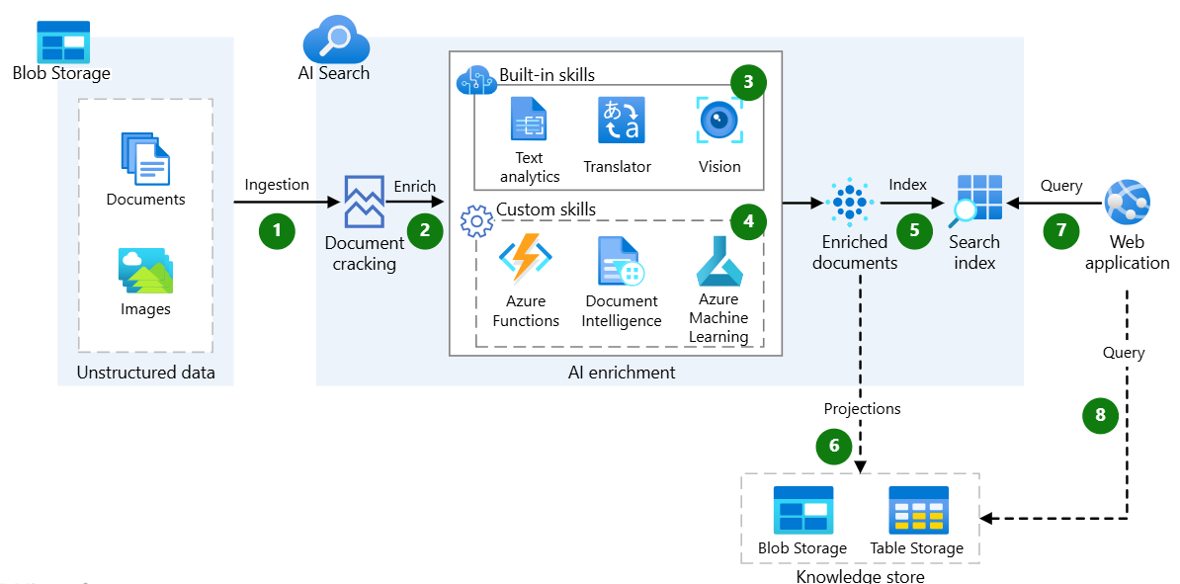

Logical Architecture Components

5.1 Data Sources
Azure Blob Storage
- Primary repository for documents and images
- Supports unstructured and mixed-media content
- Integrates natively with Azure AI Search indexers

5.2 AI Enrichment Layer
Azure AI Search Skillsets
- Reusable enrichment definitions attached to indexers
- Execute after content extraction
- Composed of multiple skills operating on an in-memory enrichment tree
Built-in Skills
- OCR (image text extraction)
- Language detection
- Entity recognition
- Key phrase extraction
Custom Skills
- Azure Functions
- Azure Machine Learning models
- Document Intelligence services
Skillsets enrich documents by adding structured data nodes to the enrichment tree, which can then be indexed or projected.

5.3 Indexing and Storage Layer
Azure AI Search Index
- Stores searchable enriched content
- Supports full-text, faceted, and filtered queries
Knowledge Store (Optional)
- Persists enriched outputs in Azure Storage
- Enables analytics, reporting, and data science workloads
- Supports structured consumption outside of search scenarios

5.4 Search and Consumption Layer
- Business applications
- Reseller or customer portals
- Knowledge mining solutions
- API-based integrations
Users query enriched content via Azure AI Search endpoints.

Architectural Best Practices

6.1 Azure Well-Architected Framework Alignment
Pillar | Implementation Approach
Reliability | Managed services and resilient indexing pipeline
Security | RBAC, managed identities, encrypted storage
Performance | Scalable index partitions and replicas
Cost Optimization | Skill reuse and enrichment caching
Operational Excellence | Automated indexing and monitoring
Azure AI Search skillsets are designed to operate within Microsoft-defined well-architected principles.

6.2 Governance & Lifecycle Management
- Version-controlled skillsets
- Centralized index schema definitions
- Controlled promotion across environments
- Monitoring and diagnostics through Azure Monitor
These controls ensure repeatable, auditable enrichment pipelines.

6.3 Security and Responsible AI
- Secure access to Blob Storage and Search service
- Restriction of custom skill endpoints
- Monitoring of AI outputs for accuracy and bias
- Separation of sensitive enriched data where required
Azure AI Search skillsets support Microsoft Responsible AI principles through controlled AI enrichment workflows

Cloud Center of Excellence Enablement Model
The Cloud Center of Excellence:
- Owns and governs approved AI Search architectures
- Maintains reusable skillset templates
- Defines enrichment standards and policies
- Provides technical guidance to resellers
- Ensures consistency across regions and workloads
This governance model satisfies the Cloud Center of Excellence requirements defined in the Frontier Distributor checklist.

Reusability and Scalability
This reference architecture:
- Supports large-scale, enterprise content repositories
- Applies consistently across industries
- Enables through-channel AI delivery models
- Scales horizontally with content volume and AI workload complexity

Conclusion
This Cloud Center of Excellence reference architecture provides a Microsoft-aligned, audit-ready, and repeatable implementation model for AI-enriched search solutions using Azure AI Search skillsets. It enables distributors to deliver intelligent content discovery solutions while maintaining governance, security, and architectural excellence across the partner ecosystem.

